**The control plane:** The control plane is the brain of the router. It consists of dynamic IP routing protocols (that is OSPF, IS-IS, BGP, and so on), the RIB, routing updates, in addition to other protocols such as PIM, IGMP, ICMP, ARP, BFD, LACP, and so on. In short, the control plane is responsible for maintaining sessions and exchanging protocol information with other router or network devices.

In centralized architecture platforms, the general-purpose CPU manages all control plane protocols. In distributed architecture platforms, routing protocols, and most other protocols, always run on the core CPU in the RPs or Supervisor engines, but there are other control plane protocols such as ARP, BFD, and ICMP that in some distributed architecture platforms have now been offloaded to the line card CPU.

**The data plane:** The data plane is the forwarding plane, which is responsible for the switching of packets through the router (that is, process switching and CEF switching). In the data plane, there could be features that could affect packet forwarding such as quality of service (QoS) and access control lists (ACLs).

**The management plane:** The management plane is used to manage a device through its connection to the network. Examples of protocols processed in the management plane include Simple Network Management Protocol (SNMP), Telnet, File Transfer Protocol (FTP), Secure FTP, and Secure Shell (SSH). These management protocols are used for monitoring and for command-line interface (CLI) access.

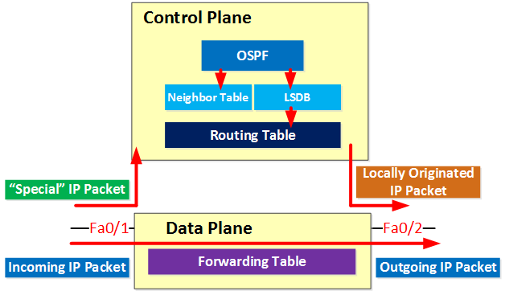

**Special** =

IP packets that are destined for one of the IP addresses of the router / multilayer switch.

Routing protocol traffic like OSPF, EIGRP or BGP.

IP packets that have some of the options set in the IP header.

IP packets with an expired TTL.

RIB = Routing information base = Routing table

FIB = Forwarding information base (Forwarding table) e.g. CEF table